Year 10 – Economics and Business – Revision

Test Topics include:

- Key Concepts of Economics and Business
- What is Economics? The Economic Problem (Scarcity)
- Economic Activity
- Economic Performance – Key indicators:
- Economic Growth (GDP)
- Inflation (CPI)
- Unemployment (Rate)
- Unemployment – Types
- The Business Cycle – Phases
- HDI

- State the six key concepts of economics and business by filling in the blanks!

- Scarcity
- Making Choices
- Specialisation and Trade
- Interdependence
- Allocation and Markets
- Economic Performance and Living Standards
- Describe what the study of economics is.

Economics is a social science (study of human behaviour) that analyses the decisions made by individuals, businesses and governments about how limited resources are used to satisfy society’s unlimited needs and wants. For example we can look at how a country such as Australia aims to manage the economy in order to achieve prosperity and increased standards of living for its population.

- Define what economic activity is.

Economic activity refers to all the actions involved in producing, distributing and consuming goods and services. Rising economic activity is often associated with increasing standards of living.

- In the table below, complete each section about the Key Indicators of Economic Performance.
Key Indicator | Economic Growth | Inflation | Unemployment Rate
Definition | Economic growth is defined as real growth in the volume (value) of goods and services produced by an economy over a period of time. A measurement of the increase in a country’s gross domestic product (GDP) | Inflation a general rise in the prices of goods and services within an economy. | To be considered unemployed a person must not currently have a job, be willing and able to work and actively seeking work.
How is it calculated? | GDP  The most commonly used general measure of this is the annual rate of growth in real gross domestic product (GDP). GDP represents the total market value of final goods and services produced by a country over a period of time.  Aggregate Demand = C + I + GI + GS + X – M) ** do not need to know | CPI  Inflation measured by calculating the Consumer Price Index (CPI). The CPI measures the average change in retail price of a basket of local and imported goods and services | The Unemployment Rate tells us the proportion of the labour force that is currently unemployed.  The unemployment rate is measured using the Labour Force Survey. Where the proportion of people who are “unemployed” from the labour force is measured. The ABS defines the labour force as people who are older than 15 years and who are able and willing to work.
Australia’s Target | 3 – 4% | 2 – 3% | 4.5 – 5%
Australia’s Current Measurement | 4.2% | 5.1% | 4.0%

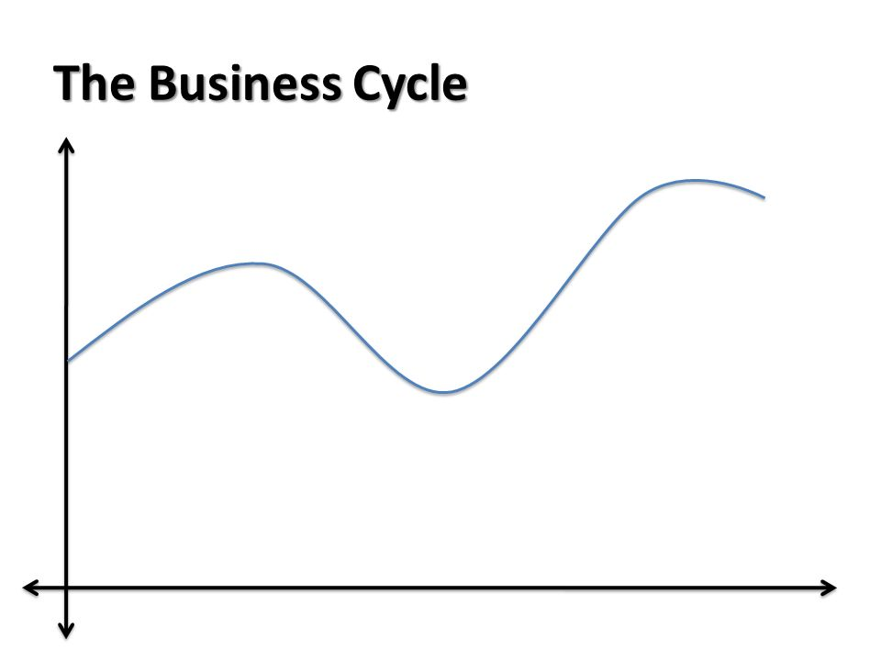
- Label the four phases of the business cycle on the diagram below:
Real GDP
Time
Expansion/Upswing
Contraction/Downswing
Trough
Peak
Peak

- Causes of Unemployment – 4 main types of unemployment. Read the information below and identify the type of unemployment.

- Occurs when people are unemployed between finishing one job and starting another. E.g. building trades, areas of rural industry

Frictional
- Occurs when the level of spending in the economy falls. When businesses or consumers feel negative (pessimistic) about the economy they tend to save rather than spend. Reduced spending, reducing production, and therefore reduced need for labour.

Cyclical
- Occurs as a result of changes in the way goods and services are produced. Production methods change, leading to a mismatch of skills. Job losses often linked to changes in technology. Another cause could be outsourcing.

Structural
- Results from the termination of jobs at the same time each year due to regular change in seasons. Examples: sheep shearing, working on ski fields.

Seasonal

- Ensure you know the meaning of the following key terms, match up the term with the correct definition:
Employed |  | the percentage of people in the labour force that are unemployed.
Unemployed |  | the percentage of people in the working-age population that are in the labour force.
Labour Force |  | includes people who are not in a paid job, but who are actively looking for work.
Unemployment Rate |  | includes people who are in a paid job for one hour or more in a week.
Participation Rate |  | the sum of employed and unemployed people.

- State what HDI stands for: Human Development Index

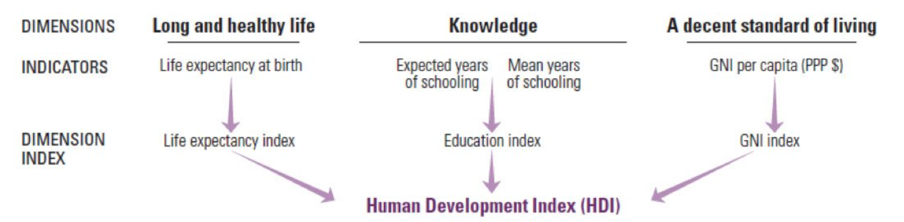
- Using the diagram below, describe what the HDI is and how it is used to give an indication of a country’s development.
The Human Development Index is a quantitative indicator that can be used to provide information about a country’s level of development. As shown in the diagram above it looks at three key dimensions of human development: a long and healthy life, knowledge and a decent standard of living. Each of these are measured using different indicators to provide an index. For example the life expectancy at birth is used to calculate the life expectancy index. The education index is calculated using two indicators; expected years of schooling and mean years of schooling. Finally, the GNI index which stands for Gross National Income is calculated using the Gross National Income date per capita. Putting these indexes together creates a score for each nation out of 1. The closer to 1.0 the higher level of development for that country.

